Wristband comparison

## Comments

The timestamp of the E4 are different from the ones got from Biovotion. E.g after converting the UTC timestamp considering the +2 time zone, the time still doesn’t correspond to the E4’s one. However from information provided by Liliana (when P1 and P2 start and finish the experiments) the E4’s timestamp seems to be the correct one. At the beginning of the P1’s experiment the time difference is about 20 minutes then it totally changes.

I take as reference the E4 timestamp since I suppose those are the moments where participants removed the wristband, so when they re-started it again a new session started.

There are data recorded on 04/09 I suppose is from another session, I won’t consider it.

The main problem is that the two wristbands are not synchronized, in order to properly compare the two I recommend to think to a way to sync them, e.g you could make a video of the moments when you switch them on and take it as reference.

From what I saw the Biovotion’s EDA signals present a lot of artefacts, it may also be that the particular device has some problems, have you used always the same device?

## IDEAs

Compute the difference in terms of timestamp between the two sensors to quantify how much is the difference.

Visual inspection to immediately understand possible difference and not-expected shape.

For signal comparison: Dynamic Time Warping, Cross-Correlation, Single Session Index,..

## Steps

### E4

1. Read the EDA.csv file and create a .csv file with EDA values and time (EDA_Time.csv). Time is extracted by converting the first element of the EDA.csv (corresponding to the unix timestamp) and considering the sampling rate of 4 Hz (4 samples for second)
2. I put the csv file of each session in a folder (file of session 1 is stored in folder 1, and so on). Folder 1,2,3 are in the folder P1 since are related to the sessions of P1, instead 4,5,6,7,8,9 are of P2.

## Comparison

### Time difference between the wristbands

After dividing the sessions (we have 9 sessions in total) I compute the difference between the timestamp obtained by the two time series (for the beginning and the end). The results:

* The time difference for the beginning of each session is [ 1702. 980. 152. 180. 6. 156. 64. 64. 70.]
* The time difference for the end of each session is [ -246. 25.5 -24. -16. 30. 921.5 18. 15. 3384.5]

Notice that the values are expressed in seconds. Even though a bit difference may be expected, due for example at different moments of switching on/off the wristbands, here we have big differences in the values (e.g 1702). Those differences make also difficult the direct comparison between the two signals. I would suggest to investigate more what is happening.

### Visual inspection

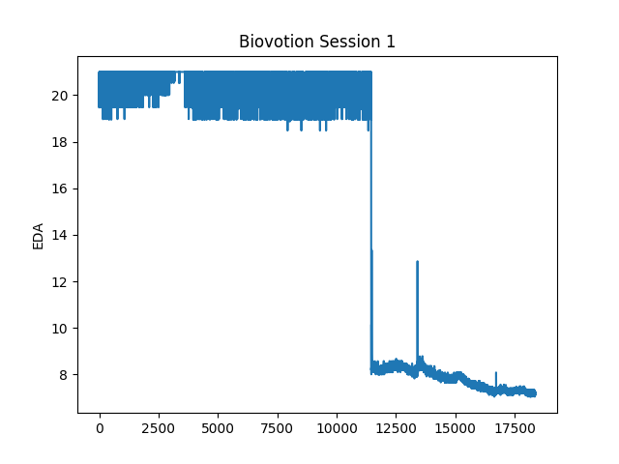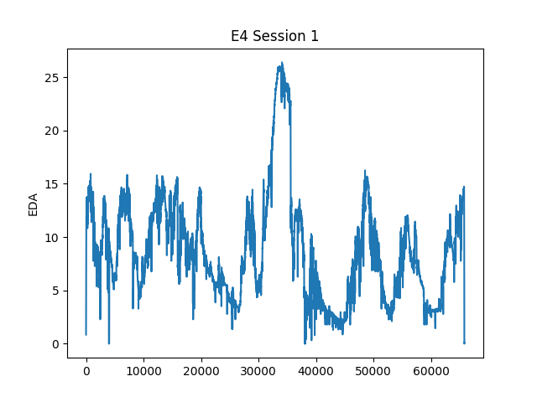First step in the comparison should be (in my opinion) a visual inspection of the signal. From session 1:

From the plots we can observe that the two signals are really different. E4 presents more samples since it’s sampled at 4 Hz, while Biovotion gives values each second directly in the raw signal. Biovotion’s signal presents higher artifacts, e.g the big spike in the values does not correspond to usual EDA’s shape.

In the first part of the signal (x values < 10000) the signal only fluctuate around 20 micro Siemens, not common in EDA. Similar artefacts are visible also in all the sessions and both participants, for example session 4 from P2. You can find also the other graphs in the correspondent folders. Even though also the signals gathered from E4 present artifacts (a pre-processing analysis is needed), the Biovotion’s EDA signal are often really different from the usual EDA. This indicates that the artifcats are not caused by the participant wearing the wristband wrongly or shaking the hand or similar source of artifacts, in my opinion the cause may be the particular wristband, I would suggest to do the experiment again using another Biovotion’s wristband.

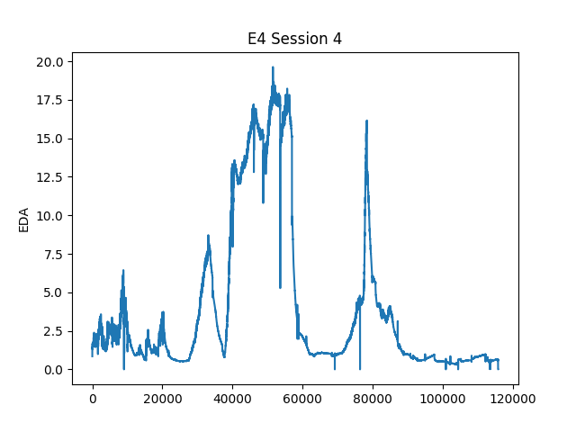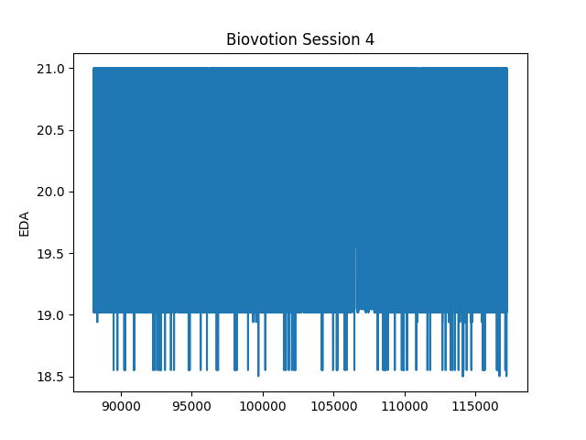

I haven’t applied any pre-processing to both the signal, as far as I understood both should provide the raw signal (E4 does it for sure, I haven’t found a lot of documentation for the Biovotion in this sense).